The 4 Best Cell Isolation Kits to Perform Tissue Dissociations

Posted by Luke Doiron on Aug 13, 2015 1:15:00 PM

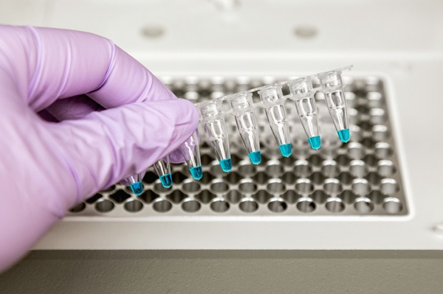
Separation of viable, high-quality cells from tumor tissue or other types of biospecimens is a critical step in biomedical research and development. The results of your research are impacted in part by the quality of the starting biospecimen as well as the methodology used to dissociate the tissues and isolate cells found in that sample. Properly prepared cell mixtures that are high in viability, purity and yield give you a positive jump-start for quality yields of RNA, proteins and other cell structures; these in turn are invaluable for downstream uses such as isolating and identifying cancer biomarkers or gene expression analysis.
Today, there are a wide variety of commercially-available kits from a range of suppliers that can be utilized for cell isolation and tissue dissociation. Here are four of the more frequently chosen systems (we make no specific endorsements of any of these products and recommend your facility do its due diligence in deciding which product would be most useful for your specific research goal).

Miltenyl Biotec
Described by the manufacturer as a fast, gentle and easy method for tissue sample dissociation, the gentleMACS Dissociation kit is available for a wide range of tissue types and offers a proprietary enzyme preparation. Tissue dissociator instruments are used in combination with so-called C Tubes or M Tubes for what is described as the gentle dissociation of tissue (C Tubes), yielding highly viable single cells, or the efficient homogenization of tissue for subsequent molecular analysis (M Tubes). MACS Tissue dissociation kits allow users to recover single cells from a variety of tissues, such as tumors, neural tissues, lung, or skin.

Worthington Biochemical
With one of the most comprehensive selections of products, resources and teaching materials for cell isolation and tissue dissociation, this company offers a very extensive range of common and specialized enzyme preparations, provided as individual items and as kits, in some cases. Its Cell Isolation Optimizing System is described by the company as a "complete method development kit," and contains a variety of enzymes that are the most frequent choices in tissue dissociation and cell isolation procedures. The kit includes instructions, references and suggestions on handling and optimizing enzymatic cell isolation protocols to achieve maximal yield and viability.

Sigma-Aldrich
This company provides a comprehensive range of dissociation enzymes as well as a stainless steel cell dissociation sieve designed to make single cell suspensions from biospecimens. Then, depending upon your research intent, you may or may not utilize enzymes for further cell isolation. Some researchers find that one of the simplest ways to separate viable cells from tumor specimens is to mince it, pass through a sieve and centrifuge the filtered cells, then re-suspend the centrifuge pellet in a growth media and culture in a flask. This avoids concerns about unacceptable cell death due to enzymatic treatment.

Roche Diagnostics
Roche supplies a wide range of tissue dissociation and cellular analysis products and kits, and highly touts its Liberase™ enzyme blends. These are described as mixtures of collagenases and neutral protease enzymes that are designed for gentle but efficient dissociation of tissue from a wide range of sources and species. These blends are said to be highly purified due to advanced fermentation conditions and an optimized purification process, which results in improved quality and reproducibility of the tissue dissociation process, as well as better viability and functionality of isolated cells.

